Thursday
Mark picks us up from the airport in the impossibly small Mitsubishi Mirage. We grab some food for Mark then drive to our Airbnb, an RV in some guy’s driveway. Spirits are high but we hit the hay early so we can get an early start.
Friday
We are up at 7am and on our way. We stop at Target for supplies, Great Harvest Bread Co. for calorie dense bread and samples! From there we hit Goodwill and finally REI in Salem. With shopping done we drove to the Willamette National Forest. The drive in was beautiful. The road followed the Santiam river through prehistoric looking redwood forest up into the mountains. We met the race directors at the start then got a campsite at Clear Lake Campgrounds. The forest is dense with massive redwoods and everything is covered in moss.
At the campsite we planned out the race. Mark spread his food out and arranged drop bags for each checkpoint. There were only 3 accessible checkpoints over the 100 miles so he had to carry his own food or rely on what the Aide Stations have.
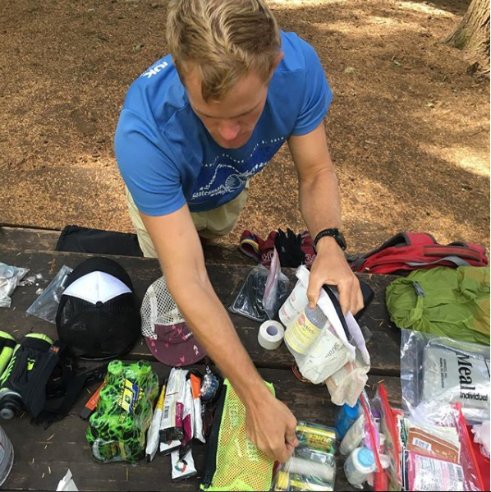
We ate sandwiches and fruit for dinner (Mark mixed peanut butter with guacamole which was oddly good). Once the sun went down and there was nothing left to do but read and sleep.
Saturday
We got up at 5am and it was very cold and dark (35 degrees F). It only took us 15min to pack and hit the road. Most racers waited for the start in their cars to keep warm. At 6:30 dawn started to break and warm things up. There was a quick safety briefing then the race started right at 7am. Mark ran past middle of the pack with a huge smile on his face.
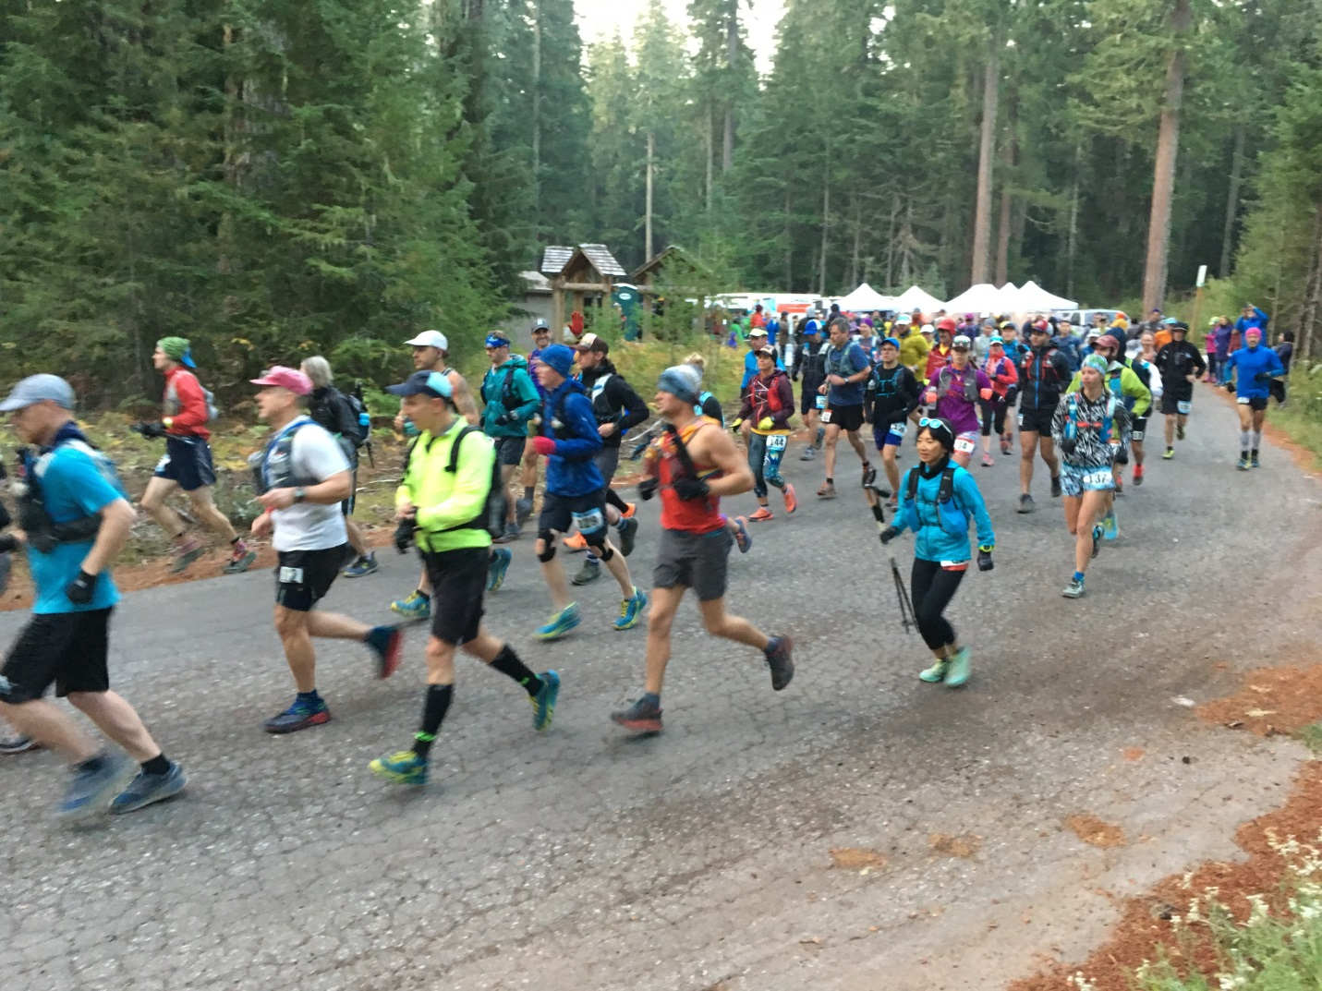
Kim and I drove out near the first aide station but ran into some really rough roads and had to turn back (the Mirage lacked clearance and a skidplate over the oil pan so we didn’t risk it). The next check point was 31 miles down the trail, so we ran errands before driving up to the “Quarry” checkpoint to wait.
The course was brutal. After leaving the start Mark climbed 2,500 ft in elevation, then dropped off 1,500 to the first aide station. The elevation continued to drop another 1,000 foot to the second aide station, then another 1,000 foot drop 4 miles into the 3rd section. Over the next 7 miles it continually climbs 3,000ft. This was the most soul destroying section. It makes up for it though with the next 4.6 miles as it was alpine ridge running through forest and exposed mountain top…possibly the most scenic section.
Mark met us at the quarry checkpoint at 1:17 and he was in 3rd place. We befriended the g/f of a Costa Rican runner and her runner came in right on Mark’s heels. Mark came in red-faced and with wide eyes he said, “that’s a lot of climbing!” He refused Gu so we had to dump and repack his food. We spent about 7 minutes restocking him and then he was off again.
The next section is an easy downhill 4 miles (1000ft), then the steepest climb 1,500 ft up to Pyramid Peak and 1,500ft right back down. From there he climbs again 1,500ft then all the way back to the finish 2,500ft below. In addition to this there was a cumulative 4,000ft in small elevation changes yielding a total of 12,500ft climb/descent per lap.
Kim and I grabbed lunch and a nap before going to the start where we would have the next handoff and I would join Mark for the next 31 miles.
Mark came in at 4th place a little after 5:30 and spent about 15-20min in the station. He changed into thermal tights, changed shoes, repacked food and got his watch charged. After we were set we headed out into the woods again. We ran around the bend at a good clip then when we hit the first hill we started speed walking. The plan was to walk all inclines and run the plateaus and descents.
The first couple miles of the trail is relatively flat and fast through a prehistoric forest. Then you start ~6 mile climb. We were pretty far in when the Costa Rican guy came up and we fell down to 5th (he ended up finishing 2nd overall). It was dark by now and as he went by I yelled, “Pura vida mon!” and he yelled back “Pura vida!” Us warm weather people need to stick together.
We got to the Aide Station at 60 miles and walked into a tent that was packed with food, heaters and people. 1st place was there because of a leg injury so we were back in 4th place. Mark said he needed time so he sat down by a heater, wrapped in an emergency blanket while a highschool kid made him quesadillas. There was a kid in the corner playing guitar and for a moment it felt (and smelled) like a European hostel in the winter. I kept handing him water/coke and at the 15min mark coaxed him out of the chair and back into the cold. In the first 20min of running he was shivering uncontrollably and I was worried about heading further in the wilderness as the temp was plunging.
Running/Walking warmed us up and we made our way 5 miles downhill to the next station. Most of this section was on an extremely steep hillside (a fall would be deadly). All I could see was what my headlamp exposed but I could feel the depth of the ravine.
At the Horse Camp aide station I could see that Mark’s energy was falling off with each stop. Nobody was at the stop so Mark sat, we put the heater in front of him and fed and hydrated. We talked about sticking to 15 min and it flew by quickly. Again, we left the station and Mark started shivering out of control…but this time we didn’t discuss, we just hiked until we got warm again.
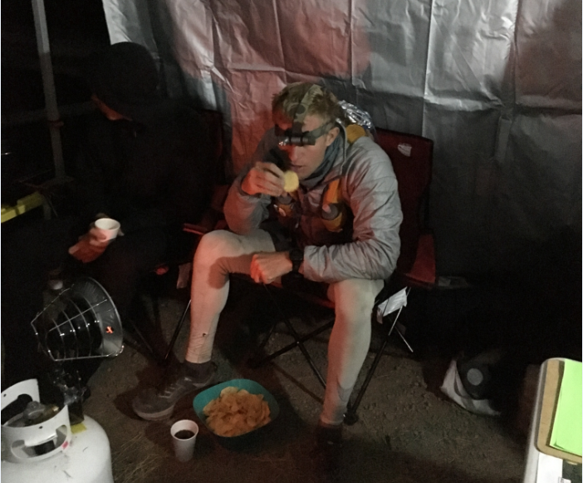
The next section was 4 miles down to a riverbed (complex crossing), then there was a 6 mile, 3,000ft climb. It seemed to never end and we were in the lowest, hardest time of the night (3am +/- 1hr). We were both tired and I was doing a poor job keeping Mark talking…he ended up talking me through it. One part was on an old abandoned road that was coated in moss. It was like walking on a padded floor and looked like a scene out of the walking dead.
We finally made it to the 75 mile check point. Mark snagged a highschool kids sleeping bag and climbed in before the kid could say something. I wanted Mark to sleep for 20 min, Mark said, “I was thinking more like 2hrs”. Mark was instantly sleeping in the dirt near a small heater. I was very miserably sitting on a small tripod seat shivering. I woke Mark at 20 min, then 40min. He still needed sleep so I had him set his alarm and told him to get to Quarry when he got up. Just before 5am I zipped up my jacket and went 5 miles down the trail to Kim and the warmth of our car.
I got to Quarry around 7am and Kim was expecting me. This was the most fun checkpoint with costume wearing attendances and Jameson next to Carbopro so I was happy to arrive. Unfortunately it went out over the radio that Mark had dropped out. We started mapping out how to get him and asked the Quarry station to radio to see if Mark was going to walk over or wait for a shuttle. The response was “the pacer went to Quarry and #3 probably will drop out”.
We realized he hadn’t dropped yet so we grabbed the map and hopped in the car. Using a GPS I got Kim to a spot on the trail a couple miles up from the checkpoint. She ran to him while I drove around. I found it 10min after they left, so Kim was able to grab him and go. It turns out the tent was full of people who were dropping and Kim had to yell from the outside, “Mark! Where are you?!?! How do I get into this tent?!?!?” Mark replied from inside, “Is that you Kim?!?!” Five minutes later they were out on the trail racing to beat the noon cutoff.
I beat them back to quarry and started prepping the handoff. I told the sweeper runner (the last person down the trail, enforces cutoffs) to wait until 12pm sharp. Some mountain bikers came by and said they saw Kim and Mark 30min behind. The sweeper asked to go again and I told her “Wait just 12 more minutes out of principal.” It was a good thing because Mark and Kim came running in at 11:58!
We poured water down his throat, refilled his bottles and jammed Oreos and bars in every pocket we could find. He was out of the checkpoint in 2 min and I could tell that he was pissed that he still had to race, but you could see that he was now 100% committed! Kim took over pacing and the sweeper was right behind them.
I used my phone and the paper map to find my way to the next checkpoint. By now I’ve become one with the Mitsubishi Mirage and I’m driving through the mountains like rally driver. This section was an easy one, 4 miles at a gradual downhill slope. A woman and her husband, Kim and Mark and the sweeper all came in after 1hr and 10 min.
Mark walked up and said, “I just want to cry man…” “Only a few more hours man…it’s practically in the bag” was all I could muster. He was soaked so I gave him my shirt and jacket and snagged some pizza from the high-schoolers. Off they went again, now to a difficult section.
In 6.5 miles they need to climb 1,500ft up, then right back down. It’s so steep on the way down that they actually went slower going down than going up. I found the last aide station, helped break it down and gathered up the last of our food. There were only 2 runners on the course now, one woman was about 30 min ahead of Mark.
I expected them at 4pm and they finally came in at 4:30. At 4pm Mark would have 3hrs to run the last 10 miles…something he could do blindfolded. With only 2.5hrs to run 10 miles (1,500ft up, then 2,000 down) it was going to be close.
They came in and Kim told me, “Look at his eyes David, he can make it!” I looked him in the eye and there was no more pain, fear or doubt. He was just intensely focused. I said something like, “Your belt buckle is 2.5hrs that way and you need to run if you are going to get it. You need to go get that #$@#& buckle!” Kim was gassed so I jumped in to pace Mark again so we left immediately. I ran behind him with a small bottle of water and a fistful of pizza. For about a mile we speed walked and ate and when he was done eating he started climbing with fresh legs. It didn’t take long before he started running and I couldn’t keep up. With him on his way I could finally relax…until I realized I was still 5 miles out in the wilderness at dusk with no light…so I ran too!
Mark crossed the finish line running a 7min mile 8 minutes before the 36hr deadline. Everybody was screaming “Go Texas!” He was emotional and exhausted. Kim wrapped him in a blanket, gave him a beer and set him by the fire with his belt buckle. The fellah running the Quarry checkpoint stayed back with his family just to see Mark come across the line. In all his years around races he’s never seen somebody cut the checkpoint so close and still make it.
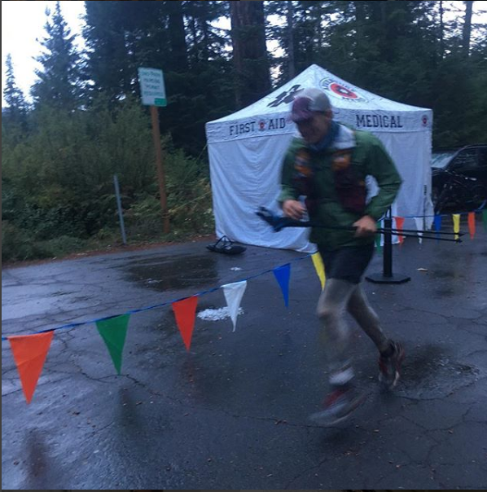
I’ve seen Mark race a lot in multiple sports over the years and from my perspective this race asked more of him than any other race. The physical toll of traveling 100 miles on foot is extreme, the elevation numbers were ridiculous (25,000ft ascent and descent) and the freezing rain was brutal. The course was remote and the hazards from falling and exposure were very serious. He finished 10th place overall and 3rd in class. The washout rate was 75%.
When we were waiting at Quarry the guy running it said there are the hardcore pro competitors who always finish well ahead of the cutoffs. Then there are the new guys who are exceptional athletes but hit a wall at mile 75…of this group only a few finish and the only thing that gets them there is an exceptional amount of grit. I’m proud of Mark for keeping it together and finishing so strong. It was impressive to witness.
